**ASSESSMENT**

MOSULE(4) WORKING WITH DATABASE USING SQL

Create a trigger that will insert a record into the employee_audit table every time a new employee

Is added to the employee is added to the employee’s table.

Ans;

-- new employee is added to employee's table trigerr

DELIMITER //

CREATE TRIGGER employees

after insert into employees

for each row

begin

insert into employee_audit(employee_id,name,position,salary,hire_date)

values(new.employee_id,new.name,new.position,new.salary,new.hire_date);

END IF;

DELIMITER //

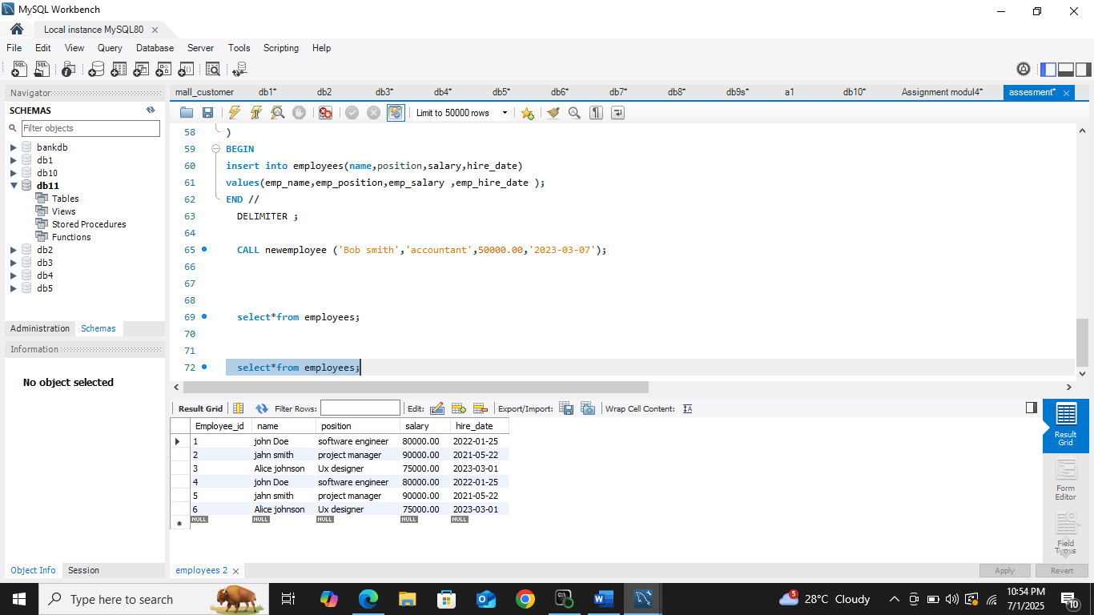

We have an employee’s table and we want to create stored procedure to add a new employee and automatically log this action in an employee_audit table.

Ans;

DELIMITER //

CREATE procedure newemployee(in emp_name varchar(100),

in emp_position varchar(100),

in emp_salary Decimal(10,2),

in emp_hire_date date

)

BEGIN

insert into employees(name,position,salary,hire_date)

values(emp_name,emp_position,emp_salary ,emp_hire_date );

END //

DELIMITER ;

CALL newemployee ('Bob smith','accountant',50000.00,'2023-03-07');

